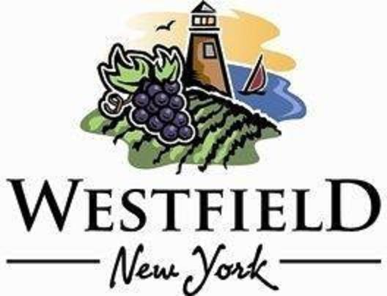

AGENDA
VILLAGE OF WESTFIELD
PLANNING BOARD

DATE: Tuesday, April 8th, 2025 PLACE: Eason Hall -North Room
TIME: 4:00 pm

- 34 Beckman Ave. 6ft. wooden fence (Jordan Ellis) SUP hearing

- 11 Franklin St. 5’ft. chain link fence (Josh & Amy Belcher) SUP hearing

- Dana Gambino to discuss a potential business for the property on the corner of N. Portage & Nichols Ave.

- March 27th Minutes review and approval

- Adjournment

